**Muon event detection via the use of simple hardware and an Android app**

**JD. Donev1, CM. Ma2, JN. Ngo3 and OQ. Qureshi4**

University of Calgary, Calgary, Alberta, Canada

soquresh@ucalgary.ca

**An Undergraduate Level Submission**

**ABSTRACT**

Muons are elementary particles that constantly bombard the Earth’s surface. Teams at MIT were able to construct and provide blueprints for a ‘household level’ muon detector which needs to be hooked to desktop PCs [1]. The work was further extended at the University of Calgary by allowing the muon detector to instead be able to communicate with mobile devices (such as Android phones). This allows the previously immobile detector to take readings at a range of locations to see comparisons in the muon event rates. Ten-minute trials with the detector were run indoors and outdoors at roughly the same height level to see the effects of wooden ceilings on muon events. We were able to note 2337 and 2500 muon events indoors and outdoors respectively. Further UI development to the Android application can set the foundation for becoming a valuable lab exercise for high school level students.

**1. Introduction**

One of the fundamental particles in the lepton family are known as muons, μ. The paper is interested specifically in ‘cosmic muons’ which are produced when high energy cosmic particles such as protons collide with molecules in the upper atmosphere. This results in the production of pions π which decay into the muons μ we are interested in. It is noted that persons having greater amounts of time at higher elevations will be exposed to greater amounts of muon events [2].

As such, our household muon counter is to detect muons created as a ‘shower’ in the Earth’s atmosphere. Physicists are interested in muon collisions because they are used in surface-based particle physics experiments in order to commission and calibrate detectors before they are exposed to beam produced by accelerators. On the other hand, many particle physics experiments are looking for rare events, and the rare signal can be swamped by the muon signal. Those experiments then must be located in deep underground laboratories [3]. It can then be noted that lower elevations with greater roofing material lowers the muon event detection, which is what we investigated in our small experiment.

**2. Android application development**

As a team of computer scientists, we worked on extending the already established physics foundation of the muon detector and focused on getting that detector to be able to communicate with mobile devices. This led to the development of an Android application from scratch as our May 2018 term project for a software engineering course. Using agile methodologies, each weekly meeting helped sculpt the final minimum viable product (MVP). The application was made in Android Studio. Testing of the application was performed using both PC emulation and a physical Android tablet. We first created a simple user interface with a title menu and recording screen, which allows the user to begin collecting data:

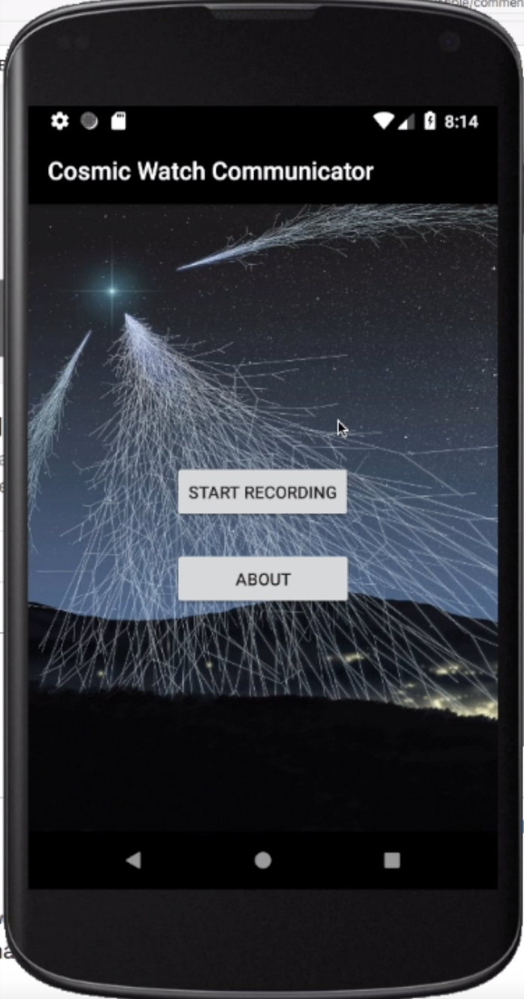 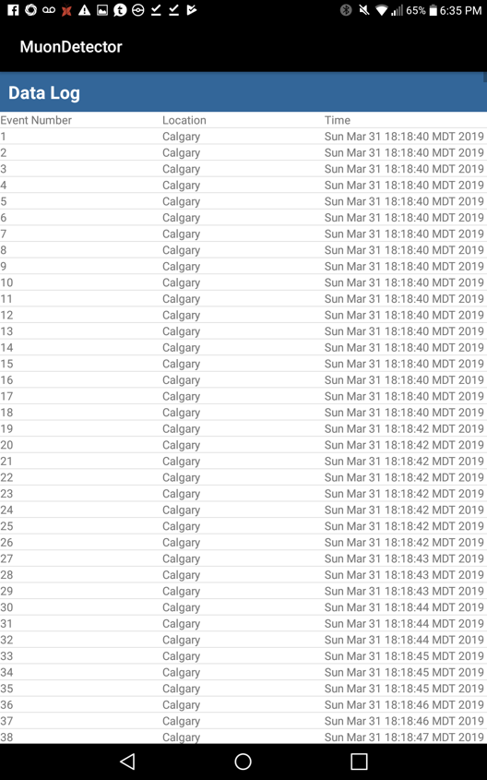

**Figure 1: Android application that communicates with the muon detector**

The main challenge after this was determining how to connect the muon detector to an Android device. A USB interface was chosen as the simplest method to implement. We eventually were able to communicate with the FTDI Arduino board used in the muon detector. This allowed us to successfully read data from the detector as comma separated values (.csv) and display it on the Android device.

By the end of the term, we had a usable app that received data from the muon detector and displayed details about muon event detection onto the screen. We continued the project after course completion, adding features such as the event log screen to show detailed information about each muon event such as date stamps. This led to us designing our own simple experiment.

**3. Experiment discussion**

Given our research for the physics behind muon events, we wanted to test whether the effect of wooden ceilings would be noticeable. We ran two ten-minute trials with the muon detector; one indoors and the other outdoors at the same height level. This led to the production of the following results:

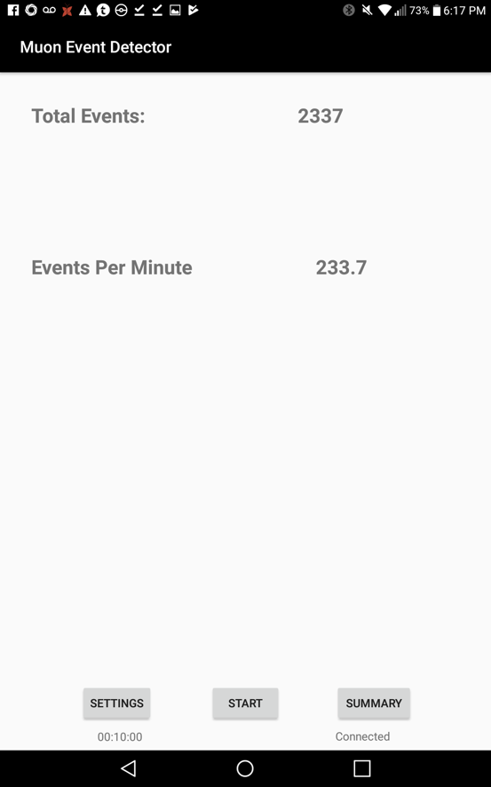 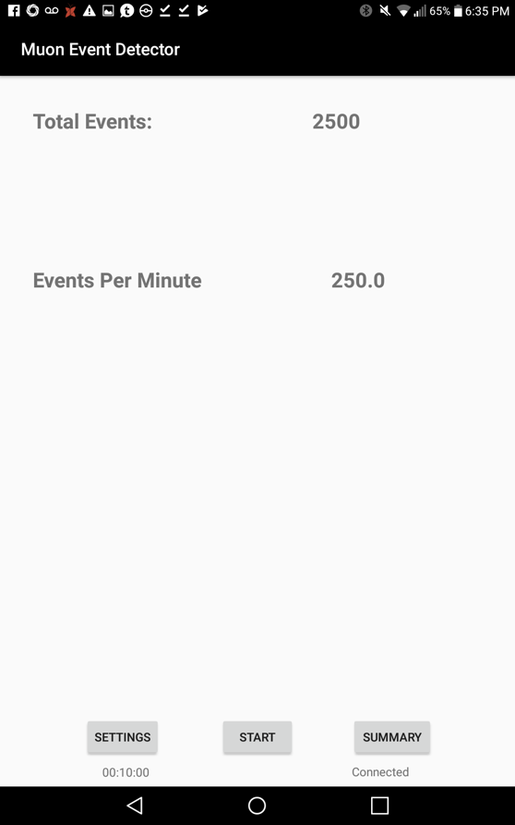

**Figure 2: Indoor (left) vs outdoor (right) total muon events over a ten-minute interval**

We noted that there were indeed fewer events detected under a ceiling which may be acting as interference. Further ideas for tests in the future involve testing different materials such as cement roofs, or varying elevations by a significant amount such as the roof of a building vs the basement of the same building.

**4. Conclusion**

The newly developed Android application allowed for the previous stationary detectors that had to be tied to an immobile desktop PC to become transportable and to be allowed to take readings in multiple locations. We were able to explore one such case with how ceilings at the same elevation interfere with muon arrival events.

Further experiments that explore varying types of ceiling material or varying elevations can now be explored. In addition, we plan to continue invest our time into polishing the application from a UI perspective and adding more features/functionality, such as the detection of latitude and longitude coordinates. We also want to be able to export the data from these mobile devices onto the cloud where they can be further processed in an application like Excel for example, since we are able to format them as comma separated values (.csv files).

We also believe that construction of the muon detector through the use of very simple, easy to acquire parts would make for an excellent lab exercise for high school students. Through the use of our application, they may be able to explore around and take varying readings across the building to note how changes in elevation and roofing effect muon events.

**5. Acknowledgements**

The team would like to acknowledge Dr. Jason Donev for continual feedback during our meetings for the progress on the project and overall guidance. Dr. Zahra Shakeri provided us with the opportunity to pursue such a project in their software engineering course. Jordan Hanania, a former fellow student, contributed to the hardware end for developing the muon detector inhouse [4]. Finally, S.N. Axani, J.M. Conrad, and C. Kirby from MIT on the blueprints for the construction of the muon detector at our campus [1].

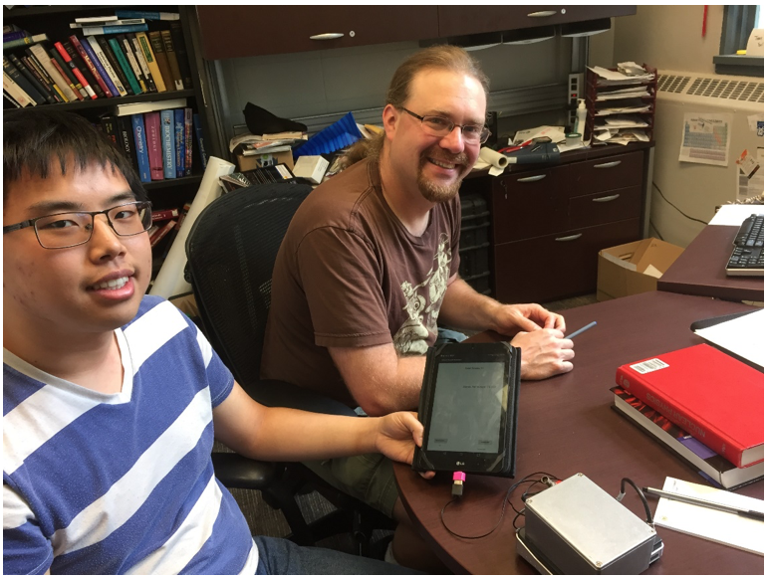

**John Ngo and Dr. Donev with the muon detector connected to an Android tablet.**

**6. References**

1. S. Axani, J. Conrad, and C .Kirby, “The Desktop Muon Detector: A simple, physics-motivated machine- and electronics-shop project for university students,". Available: https://arxiv.org/pdf/1801.03029.pdf
2. United Nations Scientific Committee on the Effects of Atomic Radiation, “Sources and effects of ionizing radiation” in *UNSCEAR 2008 Report*. New York: United Nations (published 2010). Available: http://www.unscear.org/docs/publications/2008/UNSCEAR_2008_GA-Report-CORR.pdf
3. Sanford Underground Research Facility, accessed: Mar 28, 2019 http://sanfordlab.org/
4. J. Hanania, “Development of a desktop muon detector,”. University of Calgary 2016